**Stepper Motor Interfacing with Motor Shield**

1. **Mono-Polar/UniPolar Stepper Motors**

Monopolar stepper motor have four coils and each pair of coils have a common terminal, so this motor have 6 or 5 wires.

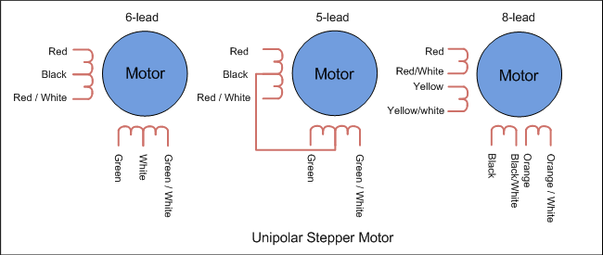

Two ways for controlling this type of stepper motor:

* First Method:

|  |  |  |  |  |
| --- | --- | --- | --- | --- |
| **Step** | **Coil A** | **Coil B** | **Coil C** | **Coil D** |
| 1 | ON | ON | OFF | OFF |
| 2 | OFF | ON | ON | OFF |
| 3 | OFF | OFF | ON | ON |
| 4 | ON | OFF | OFF | ON |

* Second Method:

|  |  |  |  |  |
| --- | --- | --- | --- | --- |
| **Step** | **Coil A** | **Coil B** | **Coil C** | **Coil D** |
| 1 | ON | OFF | OFF | OFF |
| 2 | OFF | ON | OFF | OFF |
| 3 | OFF | OFF | ON | OFF |
| 4 | OFF | OFF | OFF | ON |

Motor Shield library is designed using second method. User can use first method also by changing the sequence in code.

1. **Bi-Polar Stepper Motor**

Bipolar stepper motor have two coils, so a bipolar motor have 4 wires.

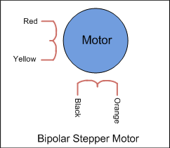

To operate stepper motor, use this sequence:

|  |  |  |  |  |
| --- | --- | --- | --- | --- |
| **Step** | **A Wire** | **B Wire** | **C Wire** | **D Wire** |
| 1 | + | - | + | - |
| 2 | + | - | - | + |
| 3 | - | + | - | + |
| 4 | - | + | + | - |

1. **Steps for Interfacing (5 or 6 Wire Stepper Motor):**

* First of all check out the common wire using multimeter and connect it with Motor Supply (+ pin) in the Motor Shield. In case of 6 wire stepper motor two wires are common and connect both of them.
* Check the order of coil wires arrangement and note the sequence of color of wires, so that motor will move in particular direction.
* Connect the coil wires into Motor 1 and Motor 2 Terminal (or you can use Motor 3 and Motor 4 Terminal). Kindly make sure order of coil wire will be in sequence, otherwise motor will not be able to rotate in particular direction.
* “STEPPER 1” is linked with Motor 1 and Motor 2 Terminal in motor shield and “STEPPER 2” is linked with Motor 3 and Motor 4 Terminal.
* Run the test code.

